You can find info on the teams here: <https://drive.google.com/open?id=0ByYRQ4Cx0_U3YXkwZktIRkVNNDg>

Things to cover:

* The kick-off (reps from XYZ attended etc.; use the attached master schedule for additional info)
* Food highlights (freshly oven baked pizza, market bucks etc.), Accenture coffee cart etc.
* High end mentors (check the mentor schedule, you can drop some company names like Google etc.) mentor schedule: <https://docs.google.com/spreadsheets/d/17wcAu-wWJCJ-9nY5YyeWOnBcaDs5hA1LYH5CbcUIpf0/edit?usp=sharing>
* Mention activities (nature walk / site tour / yoga / showers available etc.)\
* Mention our awesome judging committee (drop some company names like, the list of committee judges is in the attached master schedule)
* Mention the finale judges and Emcee (also in master schedule)
* Mention and briefly describe the three winners

General: Can you add some images or even whole tweets to the blog post to share some of the atmosphere? I didn't really take a lot of pictures – the ones I took are all on Twitter.

This past weekend was the TrafficJam hackathon where 150 engaged citzens formed teams and collaborated with local transportation experts, industry professionals and data experts to develop new tools and solutions for Toronto’s traffic troubles.

The City of Toronto and Evergreen CityWorks, co-hosted the 48 hour TrafficJam hackathon to determine how to use data and technology to create new solutions that will help minimize traffic congestion in Toronto and to better understand transportation issues.The beautiful Evergreen Brick Works stayed open for the full 48 hours and many participants found a cozy place to to sleepover.

We had excellent mentors on site all weekend long answering participant questions from Accenture, Deloitte, IBM, Thinkdata, and the City of Toronto.

During the weekend we hosted a variety of activities for participants including a nature walk where participants explored the beautiful surroundings of Evergreen Brick Works and free yoga sessions to help participants relax and release some stress from hacking all weekend.

We provided gourmet food made on site all weekend long for participants to enjoy. Evergreen provided Food vouchers from Farmers Market for lunch both Saturday and Sunday where participants got to pick from a wide selection of hot food made fresh at the market. On Saturday night we made delicious Libretto pizza cooked in Evergreen’s on-site wood-oven for dinner.

To help keep participants awake and alert our sponsor ACCENTURE set up a gourmet Espresso Bar with its own Barista making espressos, americanos and lattes .

At the end of the 48-hour hackathon period, 22 teams presented their ideas at the TrafficJam EXPO to a panel of committee judges from Deloitte, the 407 ETR, CAA, IBM, Toronto Life, ThinkData, Civic Tech TO, Uber, Open Data Exchange, TomTom and MaRS. The committe judges reviewed each submission and narrowed them down to the top 10 teams.

The 3 winners were selected from the top 10 teams by our Finale Judges Deputy Premier Deb Matthews, Stephen Buckley, General Manager of Transportation Services at the City of Toronto and Geoff Cape, Co-Founder and CEO of Evergreen at the Awards Ceremony hosted by Cabbie Richards.

The first place prize of $5,000 went to the TrafficJam Tacos. Their solution identified the streets with the least reliable traffic flow and developed interesting insights into the root cause of this problem.

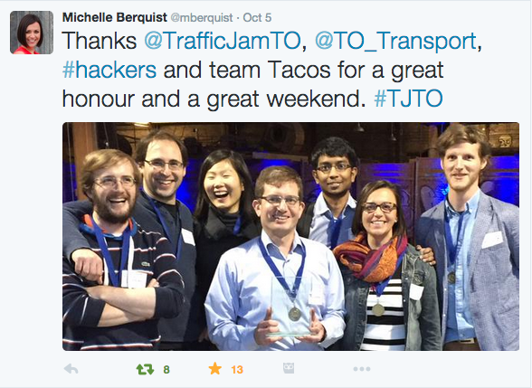

The second place prize of $2,000 went to team RueView. This group created a traffic-forecasting tool that combined historical data and real time traffic updates to provide commuters with more accurate travel times.

The third place prize of $500 went to “Three Comma Club”. Their app and website ‘Walkr’ looks at ways to improve walkability and the pedestrian experience throughout Toronto.

Congratulations to all participants who took part in the hackathon.